**Discussion**

**Objective Function Value vs. Beam Dimensions**

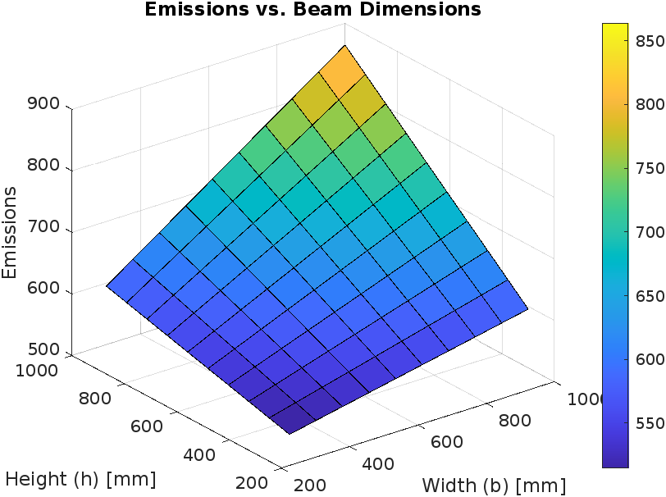

This plot illustrates how the objective function value, which is the sum of cost and emissions, varies with changes in beam dimensions. From this plot, it is evident that increasing the beam dimensions generally results in higher objective function values, indicating that larger beams lead to increased costs and emissions.

**Cost vs. Beam Dimensions**

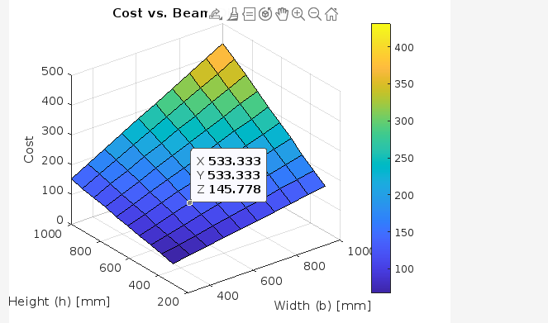

This plot clearly demonstrates that the cost increases with larger beam sizes. This observation aligns with the cost structure where larger volumes of material and additional labor contribute to higher costs.

**Emissions vs. Beam Dimensions**

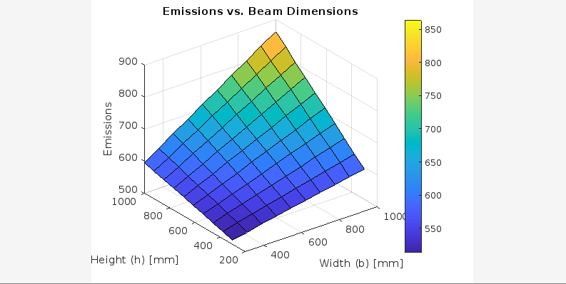

This plot reveals that as beam dimensions increase, so do the associated emissions. This emphasizes the environmental impact of larger beams highlighting the need for optimization to reduce carbon footprint.

**Design Variables vs. Objective Function:**

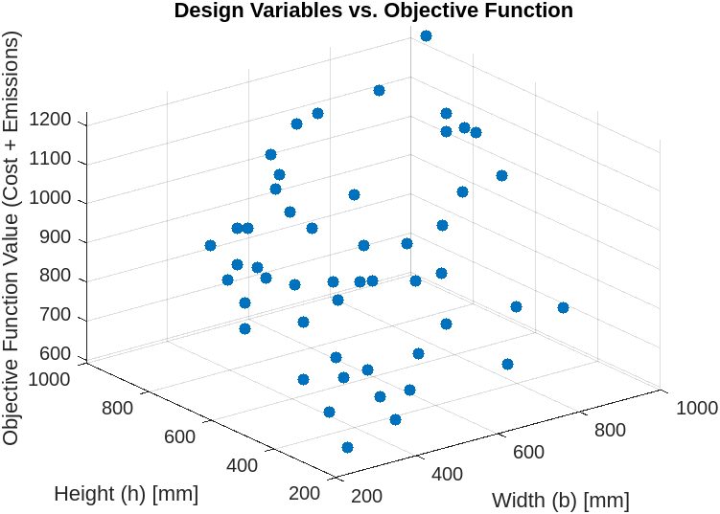

This scatter plot provides insight into how different combinations of beam width and height impact the overall objective function value. It shows the variability in objective function values based on different design choices.